Arrowhead Banquet Awards - 2022
*The nomination is confidential. To avoid possible disappointment, please do not advise nominee in any way of your action in his/her behalf. *

DISTRICT AWARD OF MERIT
The District Award of Merit is awarded to outstanding leaders who render significant service to the district, often at the district committee level. A nominee must have rendered noteworthy service to youth in Scouting, outside of Scouting, or both. Consideration is given to the nominee's position, training, tenure, and impact on the youth of the district as well as his or her accomplishments outside of Scouting. The nominee's attitude toward and cooperation with the district and council are also considerations. The award is similar to the Awards of Merit available to unit leaders but recognizes service at the district level.
The number of awards that may be presented is limited by BSA policy and nomination does not guarantee an individual will be selected to receive the award. The award is presented annually at the Arrowhead District Dinner. The award consists of an engraved plaque and a distinctive knot worn on the uniform.
DISTRICT SCOUTER AWARD District Award (for work in the District)
This award recognizes that within Scouting Districts there are persons who have worked at the District level for the past year, are known for honesty as part of their code of conduct and are dependable to a fault. They are true to their family, fellow Scouters, friends, and nation. They are concerned about others and willingly help without reward. The recipient is a friend to all and respects those with ideas and beliefs other than their own. The recipient is polite to all, regardless of age or position, understands that there is strength in being gentle, and treats others as they themselves wish to be treated. They are known to obey the Scout Law, the laws of the community and country. The recipient is known to look on the bright side, cheerfully do tasks that come their way, conserve natural resources, and carefully use time and property. They have the courage to stand for what they believe, even though it may not be what others believe. They keep their body and mind fit and clean and associate with others that live by the same ideals. They help keep the community clean and are involved in the community. The recipient is known to be reverent toward God and faithful in their religious duties, and they show respect toward others religious beliefs.
SCOUTER OF THE YEAR AWARD (Unit award for work in units (Troop/Ship/Crew); one award for every 10 units)
This award recognizes that within Scouting units, there are persons who have contributed much, often little known beyond that unit, to both the quality of its programs and its very survival through the years. Equally as often, these same persons have quietly contributed their time and talent to other units and thus to the Arrowhead District, seldom receiving the recognition they deserve. Without their consistent service, high quality scouting programs would never reach our youth. No more than 1 annual award for every 10 scouter units registered in the district.
CUB SCOUTER OF THE YEAR AWARD (Unit award for work in units (Cub Scouts); one award for every 10 units)
This award recognizes that within Cub Scouting units, there are persons who have contributed much, often little known beyond that unit, to both the quality of its programs and its very survival through the years. Equally as often, these same persons have quietly contributed their time and talent to other units and thus to the Arrowhead District, seldom receiving the recognition they deserve. Without their consistent service, high quality scouting programs would never reach our youth. No more than 1 annual award for every 10 cub scout units registered in the district.
ROOKIE OF THE YEAR District Award (District Goals) One for each: Cub Scout, Scout, Ship, Crew
This award is presented to recognize an exemplary service or accomplishment by a registered Scouter with no more than two years of total service for a project or program of such scope as to be an immediate benefit to the District. The accomplishment may be within a single unit or chartered organization only if a significant impact on District goals. One annually for Cub Scout/ Scout/ Ship/Crew.

SPOUSE OF THE YEAR District Award two annually (one per Cub level, one per Scout Troop/Ship/Crew level)
Requirements:
- Nominee must NOT be a registered Scouter.
- Nominee must exhibit positive support for his/her spouse beyond what would be considered "normal". The nominee's supportive action must have a direct impact on the nominee's spouses registered Scouting position.
Qualification Information (In what way(s) has the nominee been supportive-be specific)
SPIRIT OF BADEN POWELL District Award (work in District) - 2 awards max
This award goes to the Scouter who has “been there, done that, got the T-shirt, and received the awards” but who still has an enthusiasm that is contagious and an attitude that is an inspiration to others. This Scouter keeps giving to the youth, our District and Scouting in general. Often this person has received the District Award of Merit and/or Silver Beaver and has not been recognized for their efforts in a long time. Maximum of two awards annually.

Scout Awards
OUTSTANDING YOUTH DIST. SERVICE AWARD (Troop/Ship/Crew) District Award one to two
This unique District-level award recognizes a Venturing youth leader whose exceptional service extends beyond their own unit: providing service at District level between units, service to the community as a whole, and/or the Council. If you would like to nominate an outstanding Venture Scout for this award, please provide their name, unit number, and a written justification for the award.

Evaluation Criteria for Outstanding Eagle Project Award
The committee shall select one service project of the year from among those meeting the submission guidelines. The included criteria and other factors are all appropriate for consideration by the committee in selecting the winners. Evaluation criteria for this award should include consideration of at least the following:

- Project planning required
- Effort to develop the project
- Extent and character of the leadership provided by the Scout
- Extent of achievement of the planned result, including changes or modifications required to complete the project

- Project’s impact on the beneficiary and/or on the
community at large
- Originality of the project
- Scope of the work Time and materials contributed
Level of skill employed to complete the project

Award - $500 scholarship (money raised by donations)
(Ask for Eagle’s to bring their projects for display)
Recognize all New Eagle Scouts for the Year
Troops pay for their Eagles dinner or have a sponsor, Eagle’s Names are called and recognized. All of this year’s Eagle Scouts and their Unit will be listed in the program.

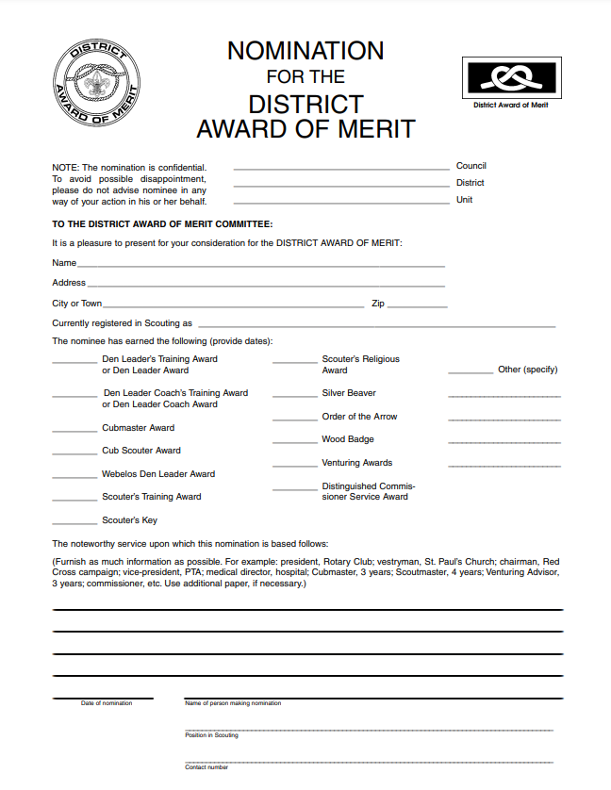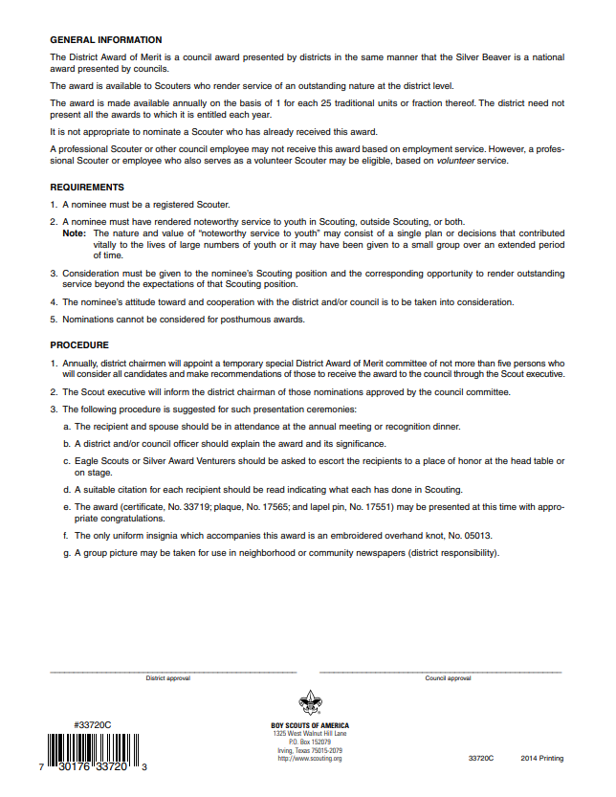

ARROWHEAD DISTRICT - LONGHORN COUNCIL - BSA
DISTRICT SCOUTER AWARD

This award recognizes that within Scouting Districts there are persons who have worked at the District level for the past year, are known for honesty as part of their code of conduct and are dependable to a fault. They are true to their family, fellow Scouters, friends, and nation. They are concerned about others and willingly help without reward. The recipient is a friend to all and respects those with ideas and beliefs other than their own. The recipient is polite to all, regardless of age or position, understands that there is strength in being gentle, and treats others as they themselves wish to be treated. They are known to obey the Scout Law, the laws of the community and country. The recipient is known to look on the bright side, cheerfully do tasks that come their way, conserve natural resources, and carefully use time and property. They have the courage to stand for what they believe, even though it may not be what others believe. They keep their body and mind fit and clean and associate with others that live by the same ideals. They help keep the community clean and are involved in the community. The recipient is known to be reverent toward God and faithful in their religious duties, and they show respect toward others religious beliefs.

ABOUT THE NOMINEE:
Nominee’s Name (as it will appear on the Award): _________________________________________________
Address__________________________________________________Phone_______________________

City________________________________________________ Zip
Current Position____________________________ Registered as Scouter since ____________________
Nominee Registered with
Unit Type: ☐ Pack ☐ Troop ☐ Crew Unit Number: _____________

Other Scouting positions held (past & present, dates, units, positions)
____________________________________________________________________________________________
____________________________________________________________________________________________
____________________________________________________________________________________________

Noteworthy awards/accomplishments (list)
____________________________________________________________________________________________
____________________________________________________________________________________________
____________________________________________________________________________________________

Why does this nominee deserve this award (accomplishment specific to this award) limit comments to this space
____________________________________________________________________________________________
____________________________________________________________________________________________
____________________________________________________________________________________________
____________________________________________________________________________________________

Does the nominee exemplify the Scout Law and the finest ideals of Scouting?
____________________________________________________________________________________________
____________________________________________________________________________________________
____________________________________________________________________________________________
Nominee’s Training Record:
☐ New Leader Essentials | ☐ Outdoor Webelos Leader (OWL) | ☐ Wood Badge
☐ Cub Scout Leader Specific | ☐ Archery/BB-Gun Instructor | ☐ The Trainer’s EDGE
☐ BALOO | ☐ Commissioner Basic | ☐ Pack / Troop /Crew Committee
☐ Scoutmaster Specific | ☐ IOLS | ☐ Varsity Coach Specific
☐ Venture Advisor Specific | ☐ Powder Horn | ☐ Other: _________________________
Nominee’s Awards Record:
☐ Tiger Cub Den Leader Award | ☐ Pack Trainer Award | ☐ Commissioner Arrowhead Honor
☐ Cub Scout Den Leader Award | ☐ Cubmaster Award | ☐ Webelos Den Leader Award
☐ Cub Scouter Award | ☐ Order of the Arrow | ☐ Ordeal ☐ Brotherhood ☐ Vigil
☐ Training/ Keys Award
☐ Other:

Recommended by

(Print name, sign, date, and phone number)

Your Name: ________________________ Your Position in the Unit: __________________________
Your Home Phone: ___________________ Your Mobile Phone: ______________________________
Your Email Address: _________________________________________________________________
Signature: _____________________________________________ Date ________________________
Will you make sure the nominee attends the Arrowhead District Dinner to receive the award? ☐ Yes ☐ No
If you check no, then the Arrowhead District Committee will notify the nominee about their award and invite them to the dinner.
Selections for the District Scouter Award must be submitted by September 30th.
Email form to: Erik Moeller – Arrowhead.Advancement@gmail.com – list “District Awards” in the subject line
ARROWHEAD DISTRICT - LONGHORN COUNCIL BSA
SCOUTER OF THE YEAR AWARD

This award recognizes that within Scouting units, there are persons who have contributed much, often little known beyond that unit, to both the quality of its programs and its very survival through the years. Equally as often, these same persons have quietly contributed their time and talent to other units and thus to the Arrowhead District, seldom receiving the recognition they deserve. Without their consistent service, high quality scouting programs would never reach our youth. No more than 1 annual award for every 10 scouter units registered in the district.

ABOUT THE NOMINEE:
Nominee’s Name (as it will appear on the Award): _________________________________________________
Address__________________________________________________Phone_______________________

City________________________________________________ Zip
Current Position____________________________ Registered as Scouter since ____________________
Nominee Registered with
Unit Type: ☐ Pack ☐ Troop ☐ Crew Unit Number: _____________

Other Scouting positions held (past & present, dates, units, positions)
_________________________________________________________________________________________
_________________________________________________________________________________________
_________________________________________________________________________________________

Noteworthy awards/accomplishments (list)
_________________________________________________________________________________________
_________________________________________________________________________________________
_________________________________________________________________________________________
_________________________________________________________________________________________
_________________________________________________________________________________________

Why does this nominee deserve this award (accomplishment specific to this award) limit comments to this space
_________________________________________________________________________________________
_________________________________________________________________________________________
_________________________________________________________________________________________
_________________________________________________________________________________________
Nominee’s Training Record:
☐ New Leader Essentials | ☐ Outdoor Webelos Leader (OWL) | ☐ Wood Badge
☐ Cub Scout Leader Specific | ☐ Archery/BB-Gun Instructor | ☐ The Trainer’s EDGE
☐ BALOO | ☐ Commissioner Basic | ☐ Pack / Troop /Crew Committee
☐ Scoutmaster Specific | ☐ IOLS | ☐ Varsity Coach Specific
☐ Venture Advisor Specific | ☐ Powder Horn | ☐ Other: _________________________
Nominee’s Awards Record:
☐ Tiger Cub Den Leader Award | ☐ Pack Trainer Award | ☐ Commissioner Arrowhead Honor
☐ Cub Scout Den Leader Award | ☐ Cubmaster Award | ☐ Webelos Den Leader Award
☐ Cub Scouter Award | ☐ Order of the Arrow | ☐ Ordeal ☐ Brotherhood ☐ Vigil
☐ Training/ Keys Award
☐ Other:

Recommended by

(Print name, sign, date, and phone number)

Your Name: ________________________ Your Position in the Unit: __________________________
Your Home Phone: ___________________ Your Mobile Phone: ______________________________
Your Email Address: _________________________________________________________________
Signature: _____________________________________________ Date ________________________
Will you make sure the nominee attends the Arrowhead District Dinner to receive the award? ☐ Yes ☐ No
If you check no, then the Arrowhead District Committee will notify the nominee about their award and invite them to the dinner.
Selections for the Scouter of the Year Award must be submitted by September 30th.
Email form to: Erik Moeller – Arrowhead.Advancement@gmail.com – list “District Awards” in the subject line
ARROWHEAD DISTRICT - LONGHORN COUNCIL BSA
CUBSCOUTER OF THE YEAR AWARD

This award recognizes that within Cub Scouting units, there are persons who have contributed much, often little known beyond that unit, to both the quality of its programs and its very survival through the years. Equally as often, these same persons have quietly contributed their time and talent to other units and thus to the Arrowhead District, seldom receiving the recognition they deserve. Without their consistent service, high quality scouting programs would never reach our youth. No more than 1 annual award for every 10 cub scout units registered in the district.

ABOUT THE NOMINEE:
Nominee’s Name (as it will appear on the Award): _________________________________________________
Address__________________________________________________Phone_______________________

City________________________________________________ Zip
Current Position____________________________ Registered as Scouter since ____________________
Nominee Registered with
Unit Type: ☐ Pack ☐ Troop ☐ Crew Unit Number: _____________

Other Scouting positions held (past & present, dates, units, positions)
_________________________________________________________________________________________
_________________________________________________________________________________________
_________________________________________________________________________________________

Noteworthy awards/accomplishments (list)
_________________________________________________________________________________________
_________________________________________________________________________________________
_________________________________________________________________________________________
_________________________________________________________________________________________
_________________________________________________________________________________________

Why does this nominee deserve this award (accomplishment specific to this award) limit comments to this space
_________________________________________________________________________________________
_________________________________________________________________________________________
_________________________________________________________________________________________
_________________________________________________________________________________________

Nominee’s Training Record:
☐ New Leader Essentials | ☐ Outdoor Webelos Leader (OWL) | ☐ Wood Badge
☐ Cub Scout Leader Specific | ☐ Archery/BB-Gun Instructor | ☐ The Trainer’s EDGE
☐ BALOO | ☐ Commissioner Basic | ☐ Pack / Troop /Crew Committee
☐ Scoutmaster Specific | ☐ IOLS | ☐ Varsity Coach Specific
☐ Venture Advisor Specific | ☐ Powder Horn | ☐ Other: _________________________
Nominee’s Awards Record:
☐ Tiger Cub Den Leader Award | ☐ Pack Trainer Award | ☐ Commissioner Arrowhead Honor
☐ Cub Scout Den Leader Award | ☐ Cubmaster Award | ☐ Webelos Den Leader Award
☐ Cub Scouter Award | ☐ Order of the Arrow | ☐ Ordeal ☐ Brotherhood ☐ Vigil
☐ Training/ Keys Award
☐ Other:

Recommended by

(Print name, sign, date, and phone number)

Your Name: ________________________ Your Position in the Unit: __________________________
Your Home Phone: ___________________ Your Mobile Phone: ______________________________
Your Email Address: _________________________________________________________________
Signature: _____________________________________________ Date ________________________
Will you make sure the nominee attends the Arrowhead District Dinner to receive the award? ☐ Yes ☐ No
If you check no, then the Arrowhead District Committee will notify the nominee about their award and invite them to the dinner.
Selections for the Cub Scouter of the Year Award must be submitted by September 30th.
Email form to: Erik Moeller – Arrowhead.Advancement@gmail.com – list “District Awards” in the subject line
.
ARROWHEAD DISTRICT - LONGHORN COUNCIL - BSA
ROOKIE OF THE YEAR
This award is presented to recognize an exemplary service or accomplishment by a registered Scouter with no more than two years of total service for a project or program of such scope as to be an immediate benefit to the District. The accomplishment may be within a single unit or chartered organization only if a significant impact on District goals. One annually for Cub Scout/ Scout/ Ship/Crew.
ABOUT THE NOMINEE:
Nominee’s Name (as it will appear on the Award): _________________________________________________
Address__________________________________________________Phone_______________________

City________________________________________________ Zip
Current Position____________________________ Registered as Scouter since ____________________
Nominee Registered with
Unit Type: ☐ Pack ☐ Troop ☐ Crew Unit Number: _____________

Other Scouting positions held (past & present, dates, units, positions)
_________________________________________________________________________________________
_________________________________________________________________________________________
_________________________________________________________________________________________

Noteworthy awards/accomplishments (list)
_________________________________________________________________________________________
_________________________________________________________________________________________
_________________________________________________________________________________________
_________________________________________________________________________________________
_________________________________________________________________________________________

Why does this nominee deserve this award (accomplishment specific to this award) limit comments to this space
_________________________________________________________________________________________
_________________________________________________________________________________________
_________________________________________________________________________________________
_________________________________________________________________________________________

Nominee’s Training Record:
☐ New Leader Essentials | ☐ Outdoor Webelos Leader (OWL) | ☐ Wood Badge
☐ Cub Scout Leader Specific | ☐ Archery/BB-Gun Instructor | ☐ The Trainer’s EDGE
☐ BALOO | ☐ Commissioner Basic | ☐ Pack / Troop /Crew Committee
☐ Scoutmaster Specific | ☐ IOLS | ☐ Varsity Coach Specific
☐ Venture Advisor Specific | ☐ Powder Horn | ☐ Other: _________________________
Nominee’s Awards Record:
☐ Tiger Cub Den Leader Award | ☐ Pack Trainer Award | ☐ Commissioner Arrowhead Honor
☐ Cub Scout Den Leader Award | ☐ Cubmaster Award | ☐ Webelos Den Leader Award
☐ Cub Scouter Award | ☐ Order of the Arrow | ☐ Ordeal ☐ Brotherhood ☐ Vigil
☐ Training/ Keys Award
☐ Other:

Recommended by

(Print name, sign, date, and phone number)

Your Name: ________________________ Your Position in the Unit: __________________________
Your Home Phone: ___________________ Your Mobile Phone: ______________________________
Your Email Address: _________________________________________________________________
Signature: _____________________________________________ Date ________________________
Will you make sure the nominee attends the Arrowhead District Dinner to receive the award? ☐ Yes ☐ No
If you check no, then the Arrowhead District Committee will notify the nominee about their award and invite them to the dinner.
Selections for the Rookie of the Year Award must be submitted by September 30th.
Email form to: Erik Moeller – Arrowhead.Advancement@gmail.com – list “District Awards” in the subject line

ARROWHEAD DISTRICT - LONGHORN COUNCIL - BSA
SPOUSE OF THE YEAR

Requirements:
- Nominee must NOT be a registered Scouter.
- Nominee must exhibit positive support for his/her spouse beyond what would be considered "normal” The nominee's supportive action must have a direct impact on the nominee's spouse’s registered Scouting position.

NOTE:

The nomination is confidential and should not be discussed in any way with the nominee.
Qualification Information (In what way(s) has the nominee been supportive-be specific)
To the District Awards Committee:

It is a pleasure to present for your consideration as the Arrowhead Spouse of the Year:

Nominee’s Name (as it will appear on the Award): ____________________________________________________
Address__________________________________________________Phone__________________________

City________________________________________________ Zip

Nominee's spouse is registered in Scouting as. ___________________________________________________

Unit Type: ☐ Pack ☐ Troop ☐ Crew Unit Number: _____________
Background information (Provide history, current employment, church member, works with youth programs)

____________________________________________________________________________________________
____________________________________________________________________________________________
____________________________________________________________________________________________
____________________________________________________________________________________________
____________________________________________________________________________________________
____________________________________________________________________________________________
____________________________________________________________________________________________
____________________________________________________________________________________________
____________________________________________________________________________________________
____________________________________________________________________________________________

Recommended by

(Print name, sign, date, and phone number)

Your Name: ________________________ Your Position in the Unit: __________________________
Your Home Phone: ___________________ Your Mobile Phone: ______________________________
Your Email Address: _________________________________________________________________
Signature: _____________________________________________ Date ________________________
Will you make sure the nominee attends the Arrowhead District Dinner to receive the award? ☐ Yes ☐ No
If you check no, then the Arrowhead District Committee will notify the nominee about their award and invite them to the dinner.
Selections for the Spouse of the Year Award must be submitted by September 30th.
Email form to: Erik Moeller – Arrowhead.Advancement@gmail.com – list “District Awards” in the subject line

ARROWHEAD DISTRICT - LONGHORN COUNCIL - BSA
SPIRIT OF BADEN POWELL

This is awarded to a Scouter who has consistently served the District for many years and has earned the esteem of his/her peers. He/she may have earned the District Award of Merit in the past but continues to actively serve the District. This Scouter exemplifies the qualities of loyalty and dedication to the District and is an example for other leaders. Maximum of two awards annually.

ABOUT THE NOMINEE:
Nominee’s Name (as it will appear on the Award): ___________________________________________________
Address__________________________________________________Phone_________________________

City________________________________________________ Zip__________________

Current Position____________________________ Registered as Scouter since ____________________

Nominee Registered with
Unit Type: ☐ Pack ☐ Troop ☐ Team ☐ Crew Unit Number: _____________
Other Scouting positions held (past & present, dates, units, positions)
____________________________________________________________________________________________
____________________________________________________________________________________________
____________________________________________________________________________________________

Noteworthy awards/accomplishments (list)
____________________________________________________________________________________________
____________________________________________________________________________________________
____________________________________________________________________________________________
____________________________________________________________________________________________
____________________________________________________________________________________________
Why does this nominee deserve this award (accomplishment specific to this award) limit comments to this space
____________________________________________________________________________________________
____________________________________________________________________________________________
____________________________________________________________________________________________
____________________________________________________________________________________________
____________________________________________________________________________________________
Does the nominee exemplify the Scout Law and the finest ideals of Scouting?
____________________________________________________________________________________________
____________________________________________________________________________________________
____________________________________________________________________________________________
____________________________________________________________________________________________

Nominee’s Training Record:
☐ New Leader Essentials | ☐ Outdoor Webelos Leader (OWL) | ☐ Wood Badge
☐ Cub Scout Leader Specific | ☐ Archery/BB-Gun Instructor | ☐ The Trainer’s EDGE
☐ BALOO | ☐ Commissioner Basic | ☐ Pack / Troop /Crew Committee
☐ Scoutmaster Specific | ☐ IOLS | ☐ Varsity Coach Specific
☐ Venture Advisor Specific | ☐ Powder Horn | ☐ Other: _________________________
Nominee’s Awards Record:
☐ Tiger Cub Den Leader Award | ☐ Pack Trainer Award | ☐ Commissioner Arrowhead Honor
☐ Cub Scout Den Leader Award | ☐ Cubmaster Award | ☐ Webelos Den Leader Award
☐ Cub Scouter Award | ☐ Order of the Arrow | ☐ Ordeal ☐ Brotherhood ☐ Vigil
☐ Training/ Keys Award
☐ Other:

Recommended by

(Print name, sign, date, and phone number)

Your Name: ________________________ Your Position in the Unit: __________________________
Your Home Phone: ___________________ Your Mobile Phone: ______________________________
Your Email Address: _________________________________________________________________
Signature: _____________________________________________ Date ________________________
Will you make sure the nominee attends the Arrowhead District Dinner to receive the award? ☐ Yes ☐ No
If you check no, then the Arrowhead District Committee will notify the nominee about their award and invite them to the dinner.
Selections for the Spirit of Baden Powell Award must be submitted by September 30th.
Email form to: Erik Moeller – Arrowhead.Advancement@gmail.com – list “District Awards” in the subject line
ARROWHEAD DISTRICT - LONGHORN COUNCIL - BSA
OUTSTANDING YOUTH DISTRICT SERVICE AWARD

This unique District-level award recognizes a Youth Leader from a Troop/Ship/Crew unit, whose exceptional service extends beyond their own unit: providing service at District level between units, service to the community, and/or to the Council. If you would like to nominate an outstanding member of a Scout Troop/Ship/Crew for this award, please provide their name, unit number, and a written justification for the award. District will Award (1-2 awards per district).

ABOUT THE NOMINEE:
Nominee’s Name (as it will appear on the Award): ____________________________________________________
Address__________________________________________________Phone__________________________

City________________________________________________ Zip__________________

Current Position____________________________ Registered as Scouter since ____________________
Nominee Registered with
Unit Type: ☐ Pack ☐ Troop ☐ Crew Unit Number: _____________
Other Scouting positions held (past & present, dates, units, positions)
____________________________________________________________________________________________
____________________________________________________________________________________________
____________________________________________________________________________________________
____________________________________________________________________________________________

Noteworthy awards/accomplishments (list)
____________________________________________________________________________________________
____________________________________________________________________________________________
____________________________________________________________________________________________
____________________________________________________________________________________________

Why does this nominee deserve this award (accomplishment specific to this award) limit comments to this space
____________________________________________________________________________________________
____________________________________________________________________________________________
____________________________________________________________________________________________
____________________________________________________________________________________________
____________________________________________________________________________________________
Does the nominee exemplify the Scout Law and the finest ideals of Scouting?
____________________________________________________________________________________________
____________________________________________________________________________________________
____________________________________________________________________________________________
Nominee’s Rank ____________________________________________________________________________ _
Was this part of an Eagle Service Project?
Nominee’s Training Record:
☐ New Leader Essentials | ☐ Outdoor Webelos Leader (OWL) | ☐ Wood Badge
☐ Cub Scout Leader Specific | ☐ Archery/BB-Gun Instructor | ☐ The Trainer’s EDGE
☐ BALOO | ☐ Commissioner Basic | ☐ Pack / Troop /Crew Committee
☐ Scoutmaster Specific | ☐ IOLS | ☐ Varsity Coach Specific
☐ Venture Advisor Specific | ☐ Powder Horn | ☐ Other: _________________________
Nominee’s Awards Record:
☐ Tiger Cub Den Leader Award | ☐ Pack Trainer Award | ☐ Commissioner Arrowhead Honor
☐ Cub Scout Den Leader Award | ☐ Cubmaster Award | ☐ Webelos Den Leader Award
☐ Cub Scouter Award | ☐ Order of the Arrow | ☐ Ordeal ☐ Brotherhood ☐ Vigil
☐ Training/ Keys Award
☐ Other:

Recommended by

(Print name, sign, date, and phone number)

Your Name: ________________________ Your Position in the Unit: __________________________
Your Home Phone: ___________________ Your Mobile Phone: ______________________________
Your Email Address: _________________________________________________________________
Signature: _____________________________________________ Date ________________________
Will you make sure the nominee attends the Arrowhead District Dinner to receive the award? ☐ Yes ☐ No
If you check no, then the Arrowhead District Committee will notify the nominee about their award and invite them to the dinner.
Selections for the Outstanding Youth District Service Award must be submitted by September 30th.
Email form to: Erik Moeller – Arrowhead.Advancement@gmail.com – list “District Awards” in the subject line

ARROWHEAD DISTRICT - LONGHORN COUNCIL BSA
OUTSTANDING EAGLE SERVICE PROJECT AWARD
Selected upon recommendation by the members of the Eagle Board of review.
Evaluation Criteria
The committee shall select one service project of the year from among those meeting the submission guidelines. The included criteria and other factors are all appropriate for consideration by the committee in selecting the winners. Evaluation criteria for this award should include consideration of at least the following:

- Project planning required
- Effort to develop the project
- Extent and character of the leadership provided by the Scout
- Extent of achievement of the planned result, including changes or modifications required to complete the project
- Project’s impact on the beneficiary and/or on the community at large
- Originality of the project
- Scope of the work Time and materials contributed
- Level of skill employed to complete the project

Award $250 scholarship for the First-place winner (money raised by donations) If the review board feels that more than one project should be recognized they may so do by placing the recipients in order (First, Second, Third)
Recipient’s Name (as it will appear on the Award): ____________________________________________________
Address__________________________________________________Phone__________________________

City________________________________________________ Zip__________________

Recipient Registered with
Unit Type: ☐ Troop ☐ Team Unit Number: _____________

If more than one recipient suggested:
2 Recipient’s Name (as it will appear on the Award): __________________________________________________
Address__________________________________________________Phone__________________________

City________________________________________________ Zip__________________

Recipient Registered with
Unit Type: ☐ Troop ☐ Crew Unit Number: _____________

3 Recipient’s Name (as it will appear on the Award): ________________________________________________________
Address__________________________________________________Phone_______________________________

City________________________________________________ Zip__________________

Recipient Registered with
Unit Type: ☐ Troop ☐ Crew Unit Number: _____________

Recommended by:

Name:___________________________________Signature____________________________

Name:___________________________________Signature____________________________

Name:___________________________________Signature____________________________

Name:___________________________________Signature____________________________

Name:___________________________________Signature____________________________

Name:___________________________________Signature____________________________

Eagle Board Committee Chairman

Name:___________________________________Signature____________________________

Date:_____________________________________

Will you make sure the nominee attends the Arrowhead District Dinner to receive the award, if selected?
☐ Yes ☐ No
If you check no, then the Arrowhead District Committee will notify the nominee about their award and invite them to the dinner.
Selections for the Outstanding Eagle Service Project Award must be submitted by September 30th.
Email form to: Erik Moeller – Arrowhead.Advancement@gmail.com – list “District Awards” in the subject line

