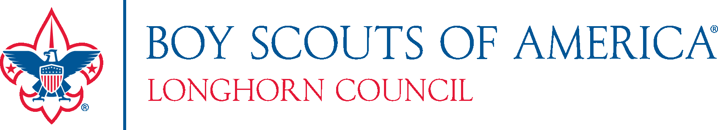

2022 Popcorn Calendar
- April 11th Begins Early Unit Popcorn sign-up available
- June 14th District Kernel Training 6pm
- Saturday, July 30th Popcorn Kickoff North 9am and South 2pm
- Sunday, August 7th Show-N- Sell Orders due by 11:59 PM
- August 25th, 26th 27th Show-N-Sell Distribution
- August 28th- October 2nd Weekly Replacements Orders due by 11:59 (each Sunday)
- September 2nd- October 7th Weekly Popcorn Replenishment Pick-up
- October 7th, 8th Popcorn Returns (8% of total original order)
- Sunday, October 16th Take Orders due by 11:59 PM
- November 4^{th,} 5th Take Order Distribution
- Monday, November 14th Popcorn Money Due (Prizes when account is zero)

2022 District Sales Goals

District | Total Units in the District | 2022 unit selling Goal | 2022 Dist. Sales Goal
41 Frontier Trails | 28 | 14 | $105,033
42 Orion | 48 | 28 | $255,690
43 Mustang | 39 | 22 | $231,845
44 Brazos Valley | 21 | 6 | $55,406
45 Pathfinder | 54 | 27 | $212,734
46 Arrowhead | 40 | 17 | $129,271
47 Trinity Trails | 29 | 8 | $75,937
48 Lonestar | 23 | 10 | $37,335
49 Santa Fe | 24 | 15 | $95,679
50 HOT | 35 | 15 | $88,777
51 Leon Valley | 27 | 17 | $95,761
52 Chisholm Trl | 29 | 10 | $107,372
Council Totals | 397 | 189 | $1,490,840

